
Adept Training (RTO 90991)

Course information

HLTSS00059
Venous blood collection skill set
Version 1_April 2026
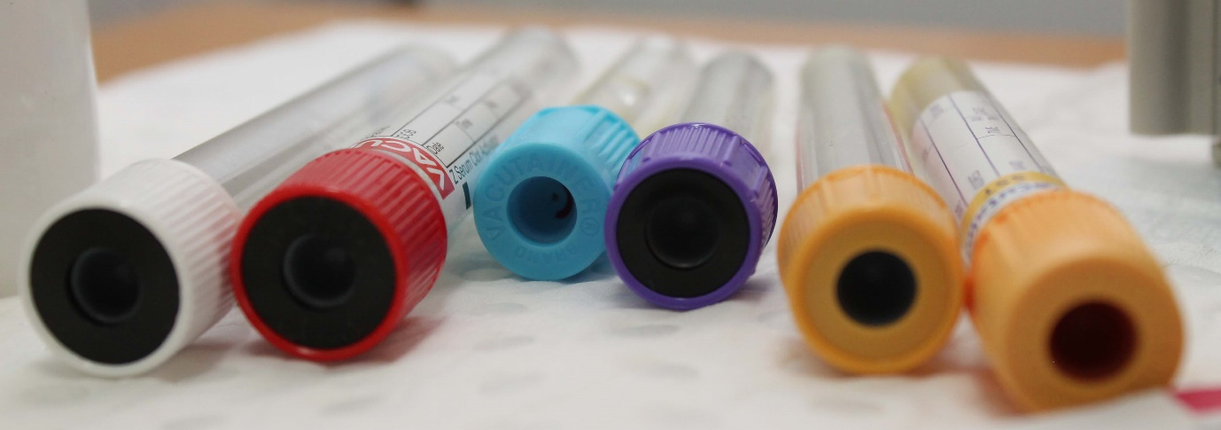

Why choose Adept Training?
Adept Training has been delivering high quality training in the healthcare space for 20 years and we are passionate and dedicated to providing the healthcare sector with skilled and competent staff. Adept Training is a Registered Training Organisation (RTO) delivering accredited qualifications through the Australian Qualifications Framework (AQF).
Adept Training prides itself on providing hands-on training that engages our students and allowing them the opportunity to develop skills and put their knowledge and learning into practice. We incorporate a range of learning styles to suit individuals and have a pool of experienced trainers and administrative staff to support everyone.
The healthcare environment is the fastest growing sector in Australia and opportunities are available in a wide range of health and community roles. Adept Training supports its learners to achieve their career goals, whether they are already in health care or aspiring to be part of this richly rewarding industry.
Course outline
HLTSS00059 Venous blood collection skill set reflects the minimum requirements for health care workers required to perform venepuncture in a clinical environment.
It is an interactive, hands-on course where you will gain the skills and knowledge to work in the rewarding field of phlebotomy. During the course you will learn how to apply infection control practices, identify and respond to clinical risks and perform venous blood collections.
Career opportunities
When you have successfully completed HLTSS00059 Venous blood collection skill set learners may be employed as a venous blood collector in a hospital, medical centre or pathology collection centre as well and other allied health services.
Delivery mode
This qualification is delivered via blended mode with online trainer led Teams sessions and face-to-face practical application of venepuncture skills at Adept Training at 83 Marion Street Harris Park.
The practical clinical skills required for pathology collection are delivered through face to face, hands on training in the college and Licensed Collection Centre (LCC) where our trainers will train and assess your knowledge and skills both in the classroom and in the workplace.

Assessments
Each unit requires that you are appropriately assessed to determine that you have gained the skills and knowledge required.
Assessment methods may include:
- Online written assessment (quizzes, multiple choice and short answer questions)
- Verbal assessment
- Online projects and case studies
- Observation of practical skills
- Work placement.
Work placement.
There is mandatory 35 hours (one week) work placement for HLTPAT014 Perform venous blood collections unit of competency which requires that students undertake placement in a pathology collection environment. Adept Training has guaranteed work placement at 4Cyte Pathology collection centre in Harris Park. This is conveniently located close to the college and students are under the mentorship and supervision of our experienced pathology collectors and trainers.
Students that wish to arrange their own work placement must pre arrange this with Adept Training.
Adept Training recognises that work experience is a great way for students to participate in the real world and apply what they have learnt in practice, however this needs to be completed in an appropriate facility that is committed to supporting our students on their learning journey.
All students going on work placement must wear the appropriated dress, shoes and behave in a manner that is respectful to the staff and healthcare environment. Students may be asked to leave a workplace if they are deemed unfit or inappropriate by the supervisor.
Insurance
Adept Training provides relevant insurance cover to all students who are undertaking work placement.
Pre – requisites
Before you commence your course, it is a requirement that every student (regardless of their background) completes a Language, Literacy, Numeracy and Digital LLN Assessment.
Students should have completed education to a year 10 level.
Careers in health care usually require a clear Police Check, and a Working with Children Check. Immunisation, while not a requirement to undertake training, Adept Training strongly recommends that our students have these in place, as they may be a requirement in some workplaces.
Students will need access to a computer (a laptop or similar, not a mobile phone) and reliable internet to undertake their study and participate in online learning.

Immunisation
Many healthcare facilities require employees to have been immunised against the following:
- Hepatitis A
- Hepatitis B
- Tetanus
- Measles, Mumps and rubella
- Any other immunisations recommended by your GP.
Student handbook
Students are required to familiarise themselves with the Adept Training Student Handbook before they enrol into a course. A copy will be sent to you prior to enrolment or can be viewed on our website www.adepttraining.com.au
Children
Children are not permitted to accompany students to classes or work placement for any reason. This is a work health and safety requirement; you are required to make your own arrangements for childcare while studying at Adept Training or attending work placement.
Enrolment
Adept Training recommends that students who enrol into this course carefully consider the course requirements and are fully committed to their studies. To enrol into this course, you will need:
- Government issued colour photo ID
- A Unique Student Identifier (USI) go to www.usi.gov.au
- A completed, satisfactory Language, Literacy and Numeracy (LLN) assessment
- Completed enrolment forms.
- Proof of residency status
Fees
Course fee: $1,800
Payment plans
A $1500 deposit is required to commence training with final payment due in a fortnight.
Alternate payment options may be available.

Recognition of Prior Learning – RPL
RPL means that skills and knowledge you have achieved through previous training, work or life experience are acknowledged. RPL will be granted only where sufficient evidence is provided of competence for an entire unit of competency.
Please note that RPL will not be granted for partial units of competency. You must lodge your RPL application and have it assessed prior to your course commencing. You may be asked to attend an interview with an RPL assessor.
There is an initial application fee of $800.00 (non-refundable) plus a fee of $750.00 per Unit of Competency for which RPL is sought. If sufficient is not supplied there will be a $200 reassessment of evidence fee. If gaps are identified gap training will be provided and costs quoted on an individual basis.
As RPL can be a lengthy process we do not guarantee a timeframe, assessment of evidence provided is processed on an individual basis.
Please see our website for more information.
Credit Transfer
A Credit Transfer is granted if you have completed the same unit of competency with another Registered Training Organisation. You must grant permission to Adept Training to access your USI transcript and complete a Credit Transfer Application form. You may also be required to submit your original transcript or a JP certified copy. This will be verified with the issuing RTO and must be completed before the start of your course.
Student support
Adept Training understands that every student journey is different, and students may at times require additional support to achieve their learning outcomes. Support may be offered in the following forms:
- Access to highly qualified and professional trainers before or after class
- One on one time with a trainer if required.
- Phone, zoom and face to face mentoring with a trainer.
- Access to our friendly administrative support staff who can discuss payment options, make flexible study arrangements or assist you with deferring your course.
- Access to our closed Facebook group where there are lots of people just like you that you can chat to and discuss your study.
- Support for English can be found at https://www.service.nsw.gov.au/transaction/learn-english-through-the-adult-migrant-english-program#eligibility
Parking
There is no on-site parking at the college, however there is limited parking in and around the Harris Park area. We recommend that students use public transport when coming to the college.
Parramatta station is approximately 8-minutes’ walk and Harris Park station is approximately 2-minutes’ walk. Buses are available from Parramatta station regularly.

Course units
HLTSS00059 Venous blood collection skill set is made up of three (3) units
The course has been designed to blend both theory and practical hands-on application of healthcare skills in a holistic manner.
Unit code | Unit name
HLTINF006 | Apply basic principles and practices of infection prevention and control
HLTPAT008 | Identify and respond to clinical risks in pathology collection
HLTPAT014 | Perform venous blood collection
Timetable
Learning | Method | Session times
3 online sessions | Teams | 2.5 hours
Home study | Online | Self-paced study
Practical skills training | Face to face | 9.00am – 4.00pm
Assessment | Online and face to face theory at home and in class | Performance assessment
Assessment | Face to face practical in class or workplace | 9.00am to 4.00pm
Work placement | Pathology clinic | Minimum 35 hours

Course Duration
On average Adept Training students complete their qualification within 4 weeks, however, please note the overall duration of each course depends on the individual student’s commitment to study, attendance at classroom sessions, successful completion of all assessments and work placement.
Contact us
If you would like more information or to speak with our Student Liaison Officer, please call us on 1300 366 044. We welcome all enquiries and are happy to help you in choosing the right course for your career goals.
You will find more information on or website www.adepttraining.com.au or email us at admin@adepttraining.com.au

